**Bug Report – TutorialsNinja**

|  |  |  |
| --- | --- | --- |
| **Bug#** | **Description** | **Severity** |
| TU1-I2 | 'Thank you for registering' email is not received to the registered email address after registering an account | Minor |
| TU1-I3 | User is able to register an account by providing an invalid phone number | Minor |
| TU1-I4 | 'Telephone' field in 'Register Account' page is accepting the spaces and not showing warning message | Minor |
| TU1-I5 | 'Password' and 'Password Confirm' fields in 'Register Account' page are accepting simple passwords | Major |
| TU1-I6 | User is getting logged out on clicking Browser back button | Critical |
| TU1-I7 | User is getting logged in automatically on browsing back immediately after logout | Major |
| TU1-I8 | Email address is not getting carry forwarded from the 'Login' page to 'Forgot Your Password' page | Minor |

|  |  |
| --- | --- |
| Bug Id | TU1-I2 |

|  |  |
| --- | --- |
| Brief Summary | 'Thank you for registering' email is not received to the registered email address after registering an account |

|  |  |
| --- | --- |
| Severity | Minor |

|  |
| --- |
| Steps to Reproduce |

1. Open the Application URL

2. Click on 'My Account' dropmenu

3. Select 'Register' option

4. Enter the new User valid details into the 'Register Account' page

5. Select the 'Privacy Policy' checkbox option

6. Click on 'Continue' button

**Expected Result:**

User Account should be created and an email with the subject 'Thank you for registering' should be received by the registered email address.

**Actual Result:**

User Account is getting created, but the email with subject 'Thank you for registering' is not received to the registered email address.

|  |
| --- |
| Screenshot |

Not Applicable

Top

|  |  |
| --- | --- |
| Bug Id | TU1-I3 |

|  |  |
| --- | --- |
| Brief Summary | User is able to register an account by providing an invalid phone number |

|  |  |
| --- | --- |
| Severity | Minor |

|  |
| --- |
| Steps to Reproduce |

1. Open the Application URL

2. Click on 'My Account' dropmenu

3. Select 'Register' option

4. Enter valid details into the fields displayed on the 'Register Account' page

5. Enter invalid phone number say **abcde**into the 'Telephone' field

6. Select 'Privacy Policy' checkbox field

7. Click on 'Continue' button

**Expected Result:**

Warning message should be displayed informing the Users about the invalid phone number

**Actual Result:**

Warning message is not getting displayed, instead User account is getting created with invalid phone number

|  |
| --- |
| Screenshot |

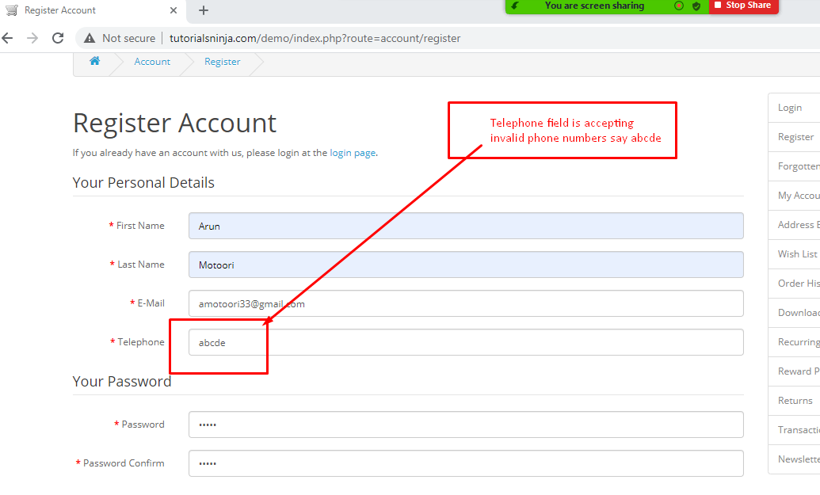

Top

|  |  |
| --- | --- |
| Bug Id | TU1-I4 |

|  |  |
| --- | --- |
| Brief Summary | 'Telephone' field in 'Register Account' page is accepting the spaces and not showing warning message |

|  |  |
| --- | --- |
| Severity | Minor |

|  |
| --- |
| Steps to Reproduce |

1. Open the Application URL in any browser
2. Click on 'My Account' dropmenu
3. Selection 'Register' option
4. Enter spaces into all the mandatory fields including 'Telephone' field
5. Select the 'Privacy Policy' checkbox field
6. Click on 'Continue' button

**Expected Result:**

Warning message informing the User to enter the Telephone field should be displayed

**Actual Result:**

Telephone field is accepting the spaces and no field level warning message is displayed for this field.

|  |
| --- |
| Screenshot |

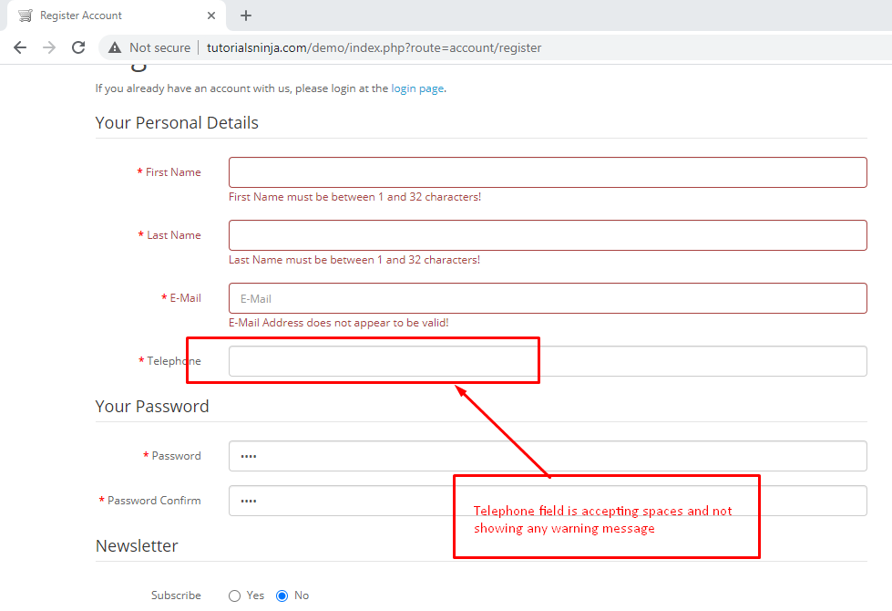

Top

|  |  |
| --- | --- |
| Bug Id | TU1-I5 |

|  |  |
| --- | --- |
| Brief Summary | 'Password' and 'Password Confirm' fields in 'Register Account' page are accepting simple passwords |

|  |  |
| --- | --- |
| Severity | Major |

|  |
| --- |
| Steps to Reproduce |

1. Open the Application URL in any browser
2. Click on 'My Account' dropmenu
3. Select 'Register' option
4. Enter details into all the mandatory fields
5. Enter simple password say 'abcd' into the 'Password' and 'Password Confirm' fields
6. Select 'Privacy Policy' checkbox field
7. Click on 'Continue' button

**Expected Result:**

Warning message informing the User to enter a password matching the complexity standards should be displayed

**Actual Result:**

Simple password got accepted and there is no warning message regarding the complexity standards of the Password.

|  |
| --- |
| Screenshot |

Not Applicable

Top

|  |  |
| --- | --- |
| Bug Id | TU1-I6 |

|  |  |
| --- | --- |
| Brief Summary | User is getting logged out on clicking Browser back button |

|  |  |
| --- | --- |
| Severity | Critical |

|  |
| --- |
| Steps to Reproduce |

1. Open Application URL in any browser
2. Click on 'My Account' dropmenu
3. Select 'Login' option
4. Enter valid email address into 'E-Mail Address' field and valid password into 'Password' field
5. Click on 'Login' button
6. Click on browser back button two times

**Expected Result**

User should not get logged out

**Actual Result**

User is getting logged out

|  |
| --- |
| Screenshot |

Not Applicable

Top

|  |  |
| --- | --- |
| Bug Id | TU1-I7 |

|  |  |
| --- | --- |
| Brief Summary | User is getting logged in automatically on browsing back immediately after logout |

|  |  |
| --- | --- |
| Severity | Major |

|  |
| --- |
| Steps to Reproduce |

1. Login to the Application
2. Click on 'My Account' dropmenu
3. Select 'Logout' option
4. Click on browser back button

**Expected Result**

User should not get logged in automatically

**Actual Result**

User is getting logged in automatically

|  |
| --- |
| Screenshot |

Not Applicable

Top

|  |  |
| --- | --- |
| Bug Id | TU1-I8 |

|  |  |
| --- | --- |
| Brief Summary | Email address is not getting carry forwarded from the 'Login' page to 'Forgot Your Password' page |

|  |  |
| --- | --- |
| Severity | Minor |

|  |
| --- |
| Steps to Reproduce |

1. Open Application URL
2. Click on 'My Account' dropmenu
3. Select 'Login' option
4. Enter email address into the 'E-Mail Address' text field
5. Click on 'Forgotten Password' link

**Expected Result:**

Email address given in Login page should get carry forwarded to 'Forgot Your Password' page

**Actual Result:**

Email address given in Login page is not getting carry forwarded to 'Forgot Your Password' page

|  |
| --- |
| Screenshot |

Not Applicable

Top